Contents

Overview 1

Logging on to Automic 1

Links to Environments 1

Automic Login Screen 2

Building a Job 3

Executing and Monitoring a job 16

Restarting/Canceling/Deactivating a Job 25

Restart a Job 26

Cancelling a Job 27

Deactivating a Job 27

# Overview

This document will provide a basic outline of the various functions of creating, executing, monitorning, troubleshooting, restarting, cancelling and deactivating a job in Automic.

# Logging on to Automic

## Links to Environments

The following links will take you to the different envirionments for Automic:

DEV: <https://atodev.mtb.com/awi>

CERT: <https://atocert.mtb.com/awi>

PROD: <https://ato.mtb.com/awi>

****NOTE****

The DEV environment logon and password will not necessarily match your LAN id/password. If you need to reset your DEV password you will need to go to the following link: <https://devstorefront.mandtbank.com/Citrix/devWeb/>

## Automic Login Screen

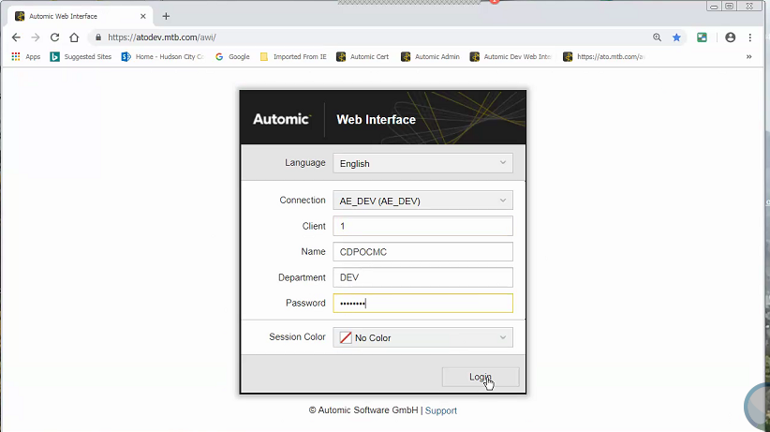

* The Connection field will be auto populated when you log into the session.
* The Client field needs to be filled.
  + Client 1 is primary client in the Dev, Cert and Prod environments that will house all of the application workflows running on Automic.
  + Each application running on Automic will have its own application client in the Dev environment only.
* The Name field is the user’s login ID.
* The Department field is optional.
* The Password field:
  + For the Dev environment the password field should be populated with the user’s DEV domain password.
  + For the Cert and Prod environments the password field should be populated with the user’s PROD domain password.
* Once all of the required fields are populated, click Login.

## Building a Job

Automic users will only have access to create Job objects in their application’s DEV clients only. Client 1 in Automic is restricted to only Automic administrators.

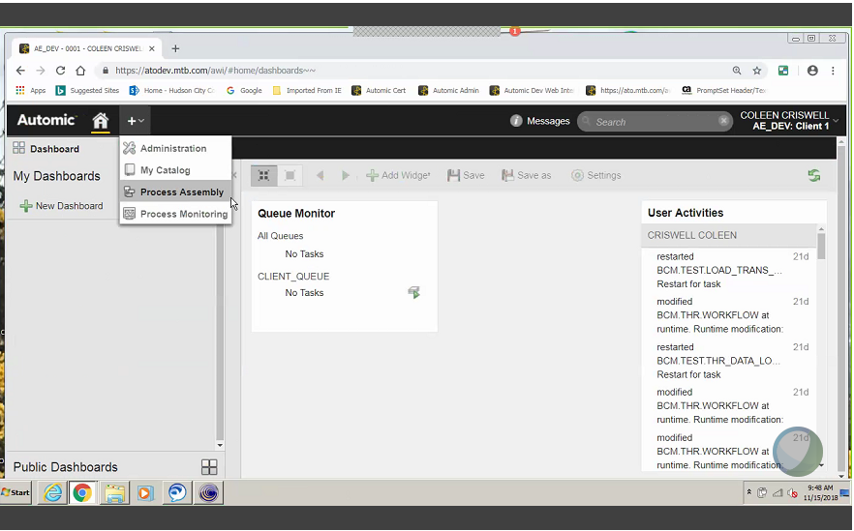

On the Automic home screen, click on the + icon next to the Home (house) icon. This will bring up a dropdown menu.

* Choose Process Assembly.

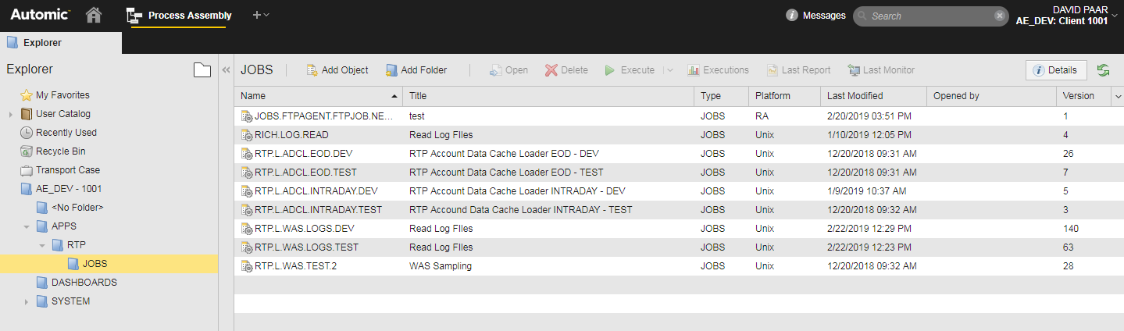

Within the process Assembly tab, Click in succession:

* The APPS folder.
* The Application Folder
* The Job Folder.
  + The user will be able to add/update the job object within the JOBS Folder.

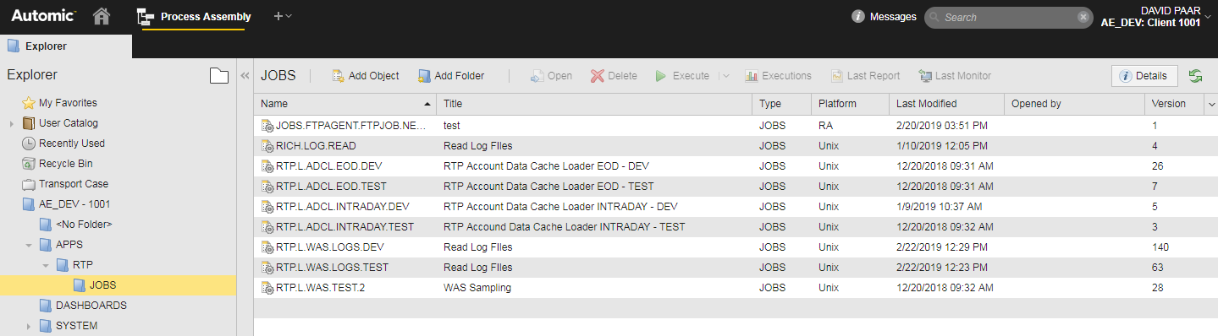

Cick on Add Object

Enter Jobs in the search bar. This will bring up the listing of all of the job-type options.

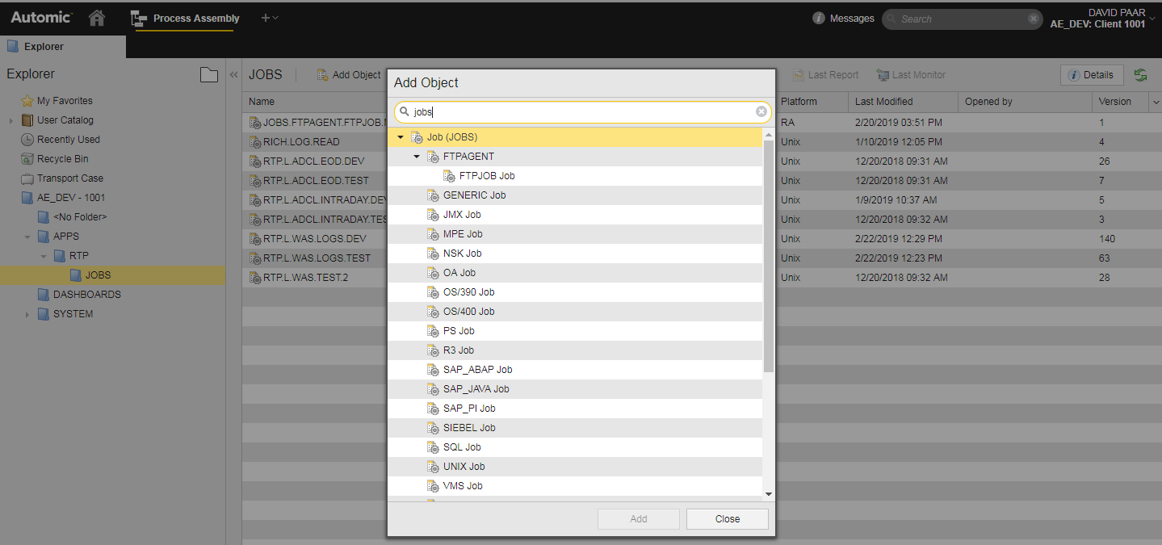

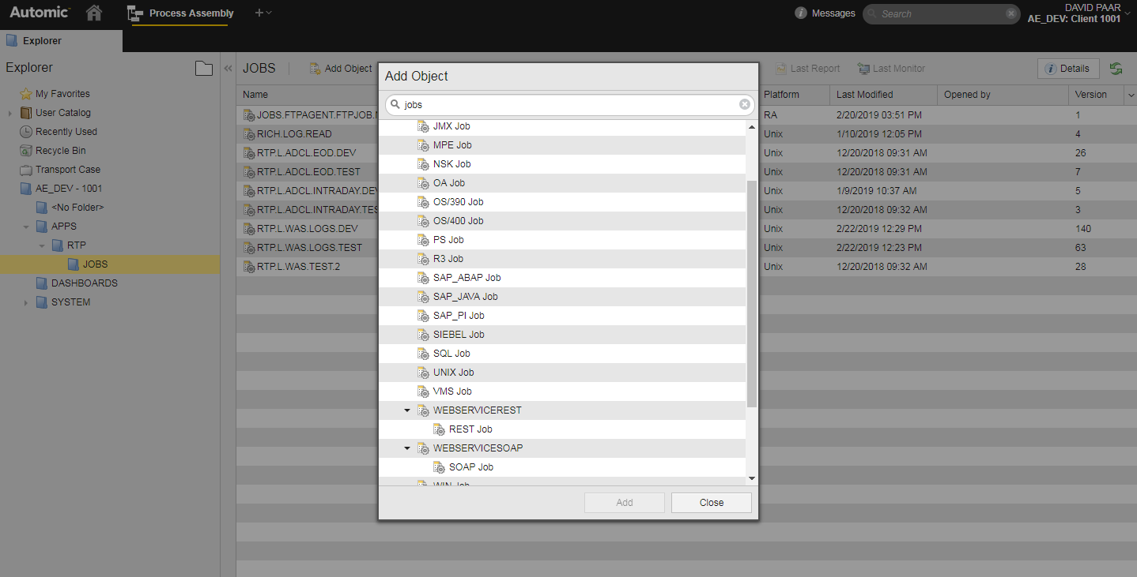

Use the scroll bar on the right of the Add Object list to select the job-type based on your operating system. The options for the Agents currently in use are based on the Operating Systems currently utilized by M&T Bank.

* If your Operating System is Windows, select Windows from the Add Object list. If your Operating System is Unix/Linux, select Unix from the Add Object list.
* Click Add.

Create job name and title for your job.

* The job name should follow the job naming convention standard currently in place for Automic jobs.
* The Title field is a free form text field that can provide additional descriptive detail about your job.

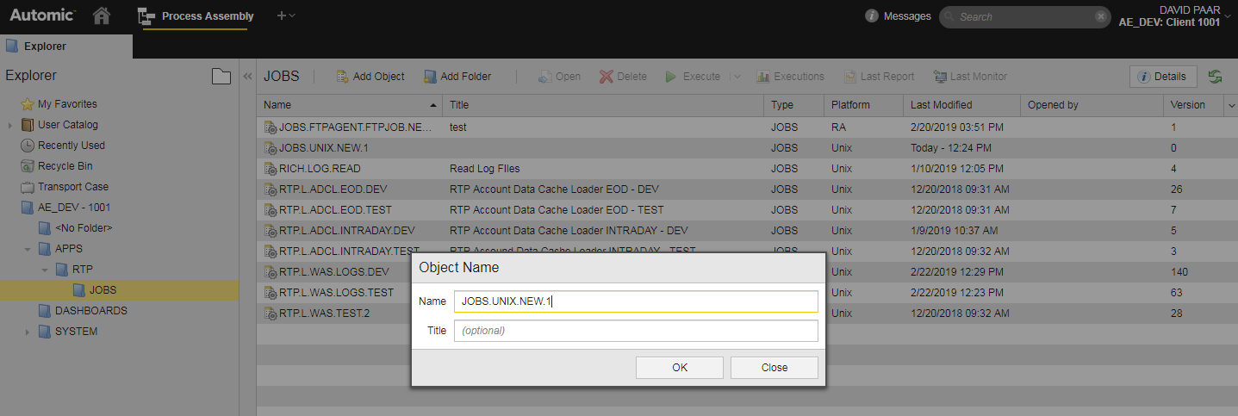

Click Ok

On the left side of the job screen, click Attributes:

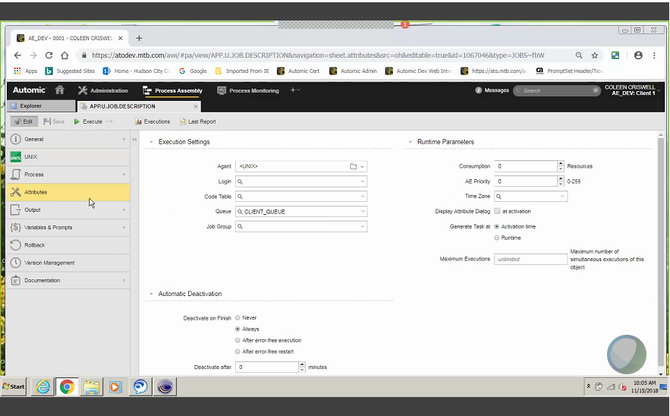

Select the Agent that will be used for the job.

* Agent names correspond with the application server name.
* Agent names can be selected by clicking on the folder icon on the right of the Agent field.
  + This will bring up a drop down list of all of the agents installed on the environment.

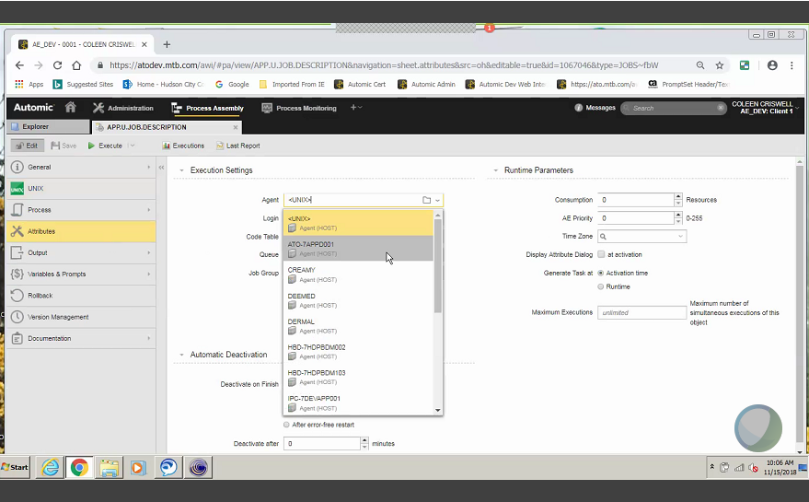

Select login object:

* In the LOGIN field:
  + Click on the down arrow on the right of the Login field and select the appropriate login object.
  + The login objects are reserved based on application code.

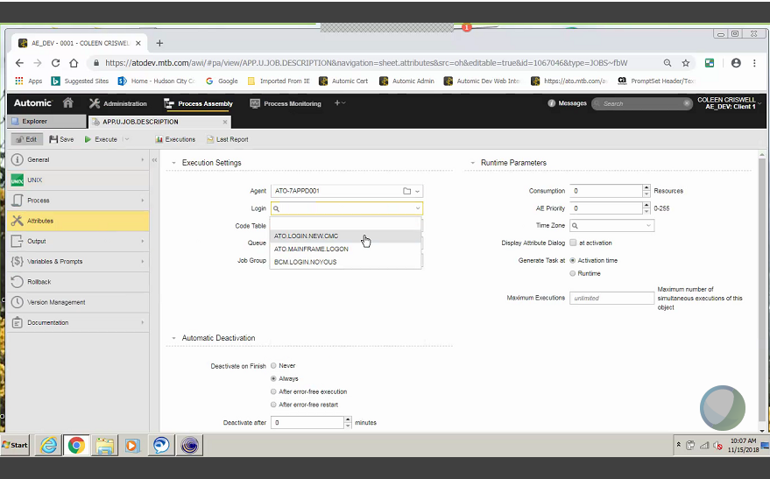

In the Automatic Deactivation Field:

* Click on ‘After error free execution’ in the Atomic Deactivation section and ANY OKAY on the Error Free Status dropdown:

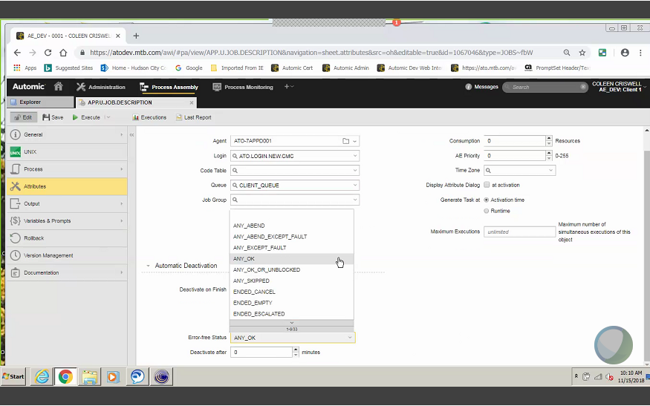

If using UNIX shell script, click on the ‘Unix’ tab:

* In the Job Type field, select whether the job will be issuing a Shell Script or a Command.

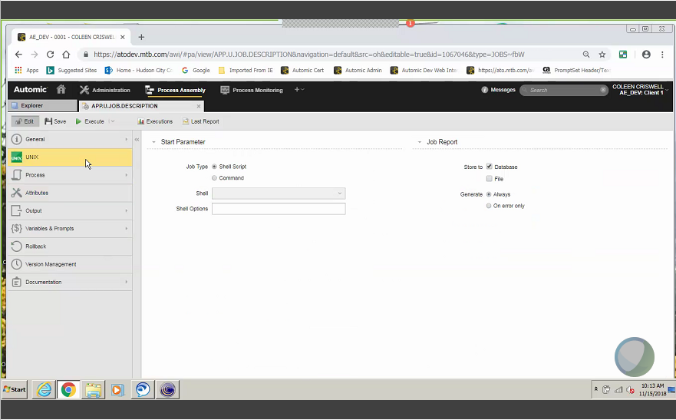

Choose Shell type with or without profile. The Shell Type represents the coding lanquage your Shell or Command is written in:

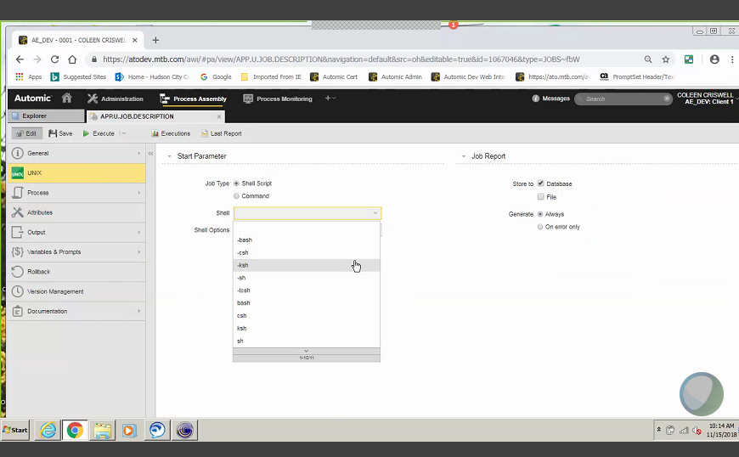

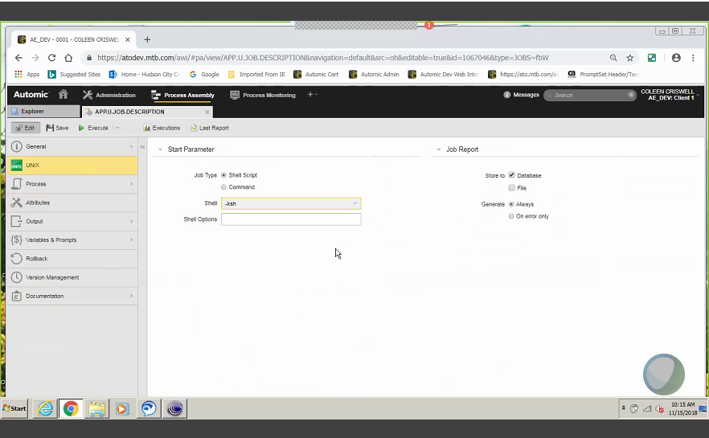

Enter the shell script in the process tab:

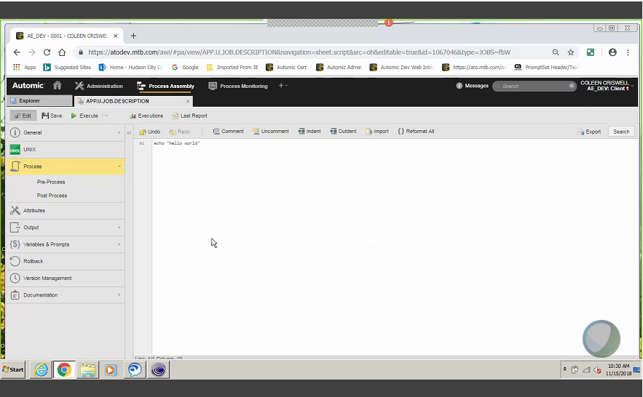

Complete the information on the documentation tab (notes)

* *****IMPORTANT******

The job will not execute unless the documentation tab (notes) is completed!

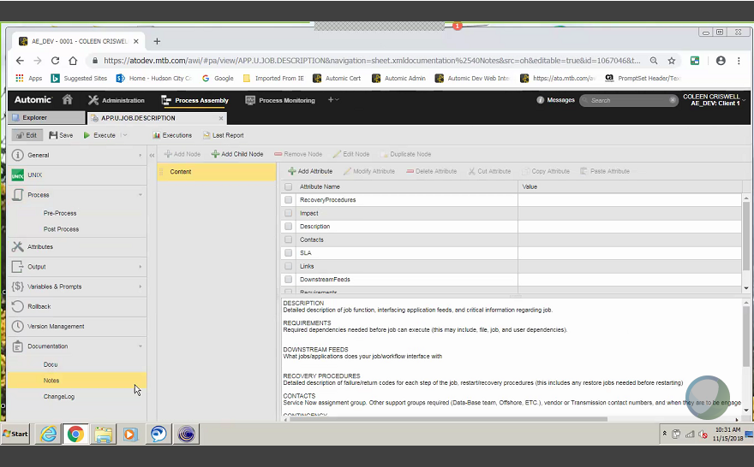

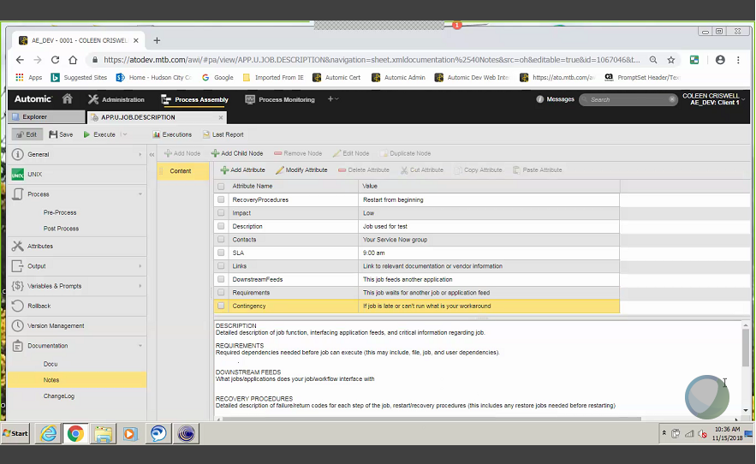

Use the DOCU tab for extended notes:

* The DOCU tab is a free form area that can contain additional information about the job or can include links to job documentation.

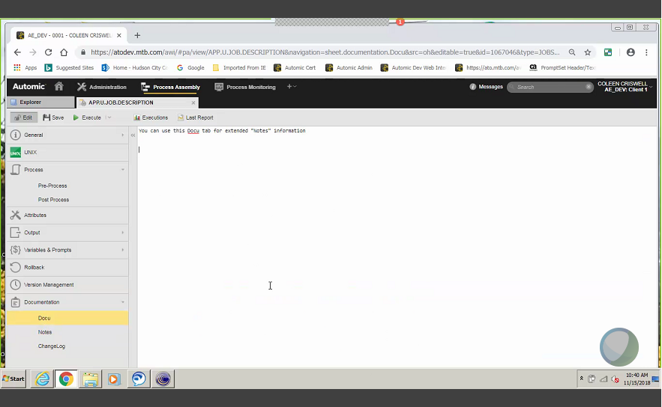

# Executing and Monitoring a job

Click on execute at the top of the Job Object screen (green right facing arrow)

* The user will be prompted whether to execute or cancel the execute request.
  + Click Execute.

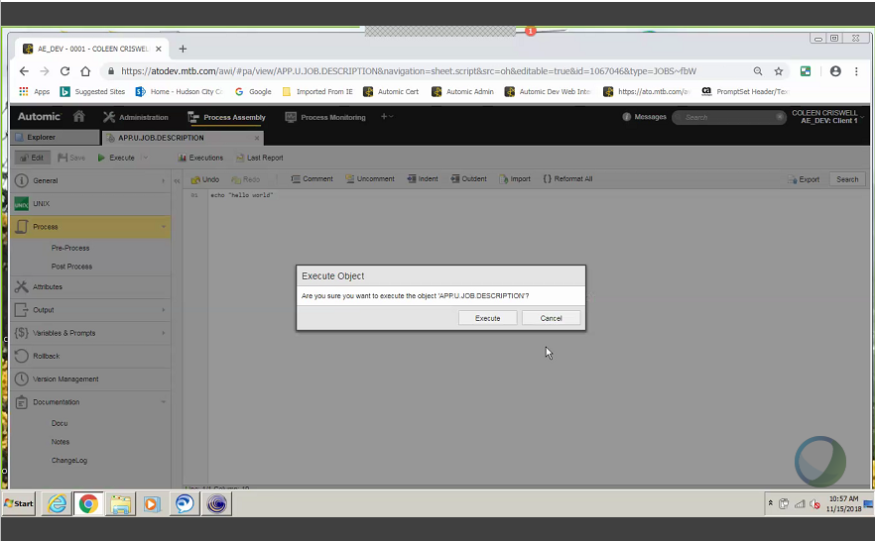

After executing the job, a Green ‘Task submitted for execution bar will appear. Click open report:

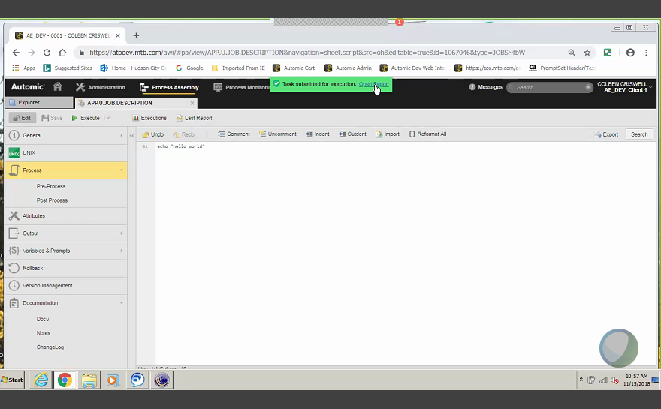

The report will display the status and the output of the job. If the job is still running, click on the refresh button on the top right of the report screen. Keep hitting refresh until the job completes.

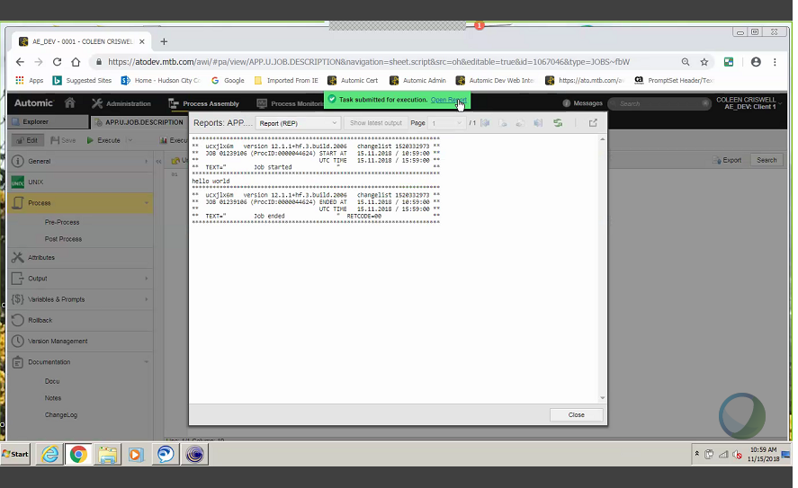

To view the status of a completed job, click on messages at the top of the screen. If the job fails, the message field will high-light in **RED** autmatically:

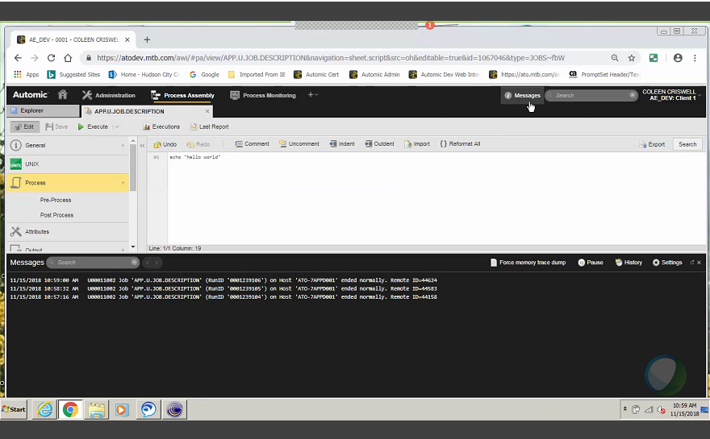

If you want to see all of the executions of a particular job, click Executions at the top of the job screen. This will bring up a listing of the current executions of the job object. ***Note****The previous executions of jobs is maintained, and output will regularly cleaned up to maintain performance on the Automic Engine:

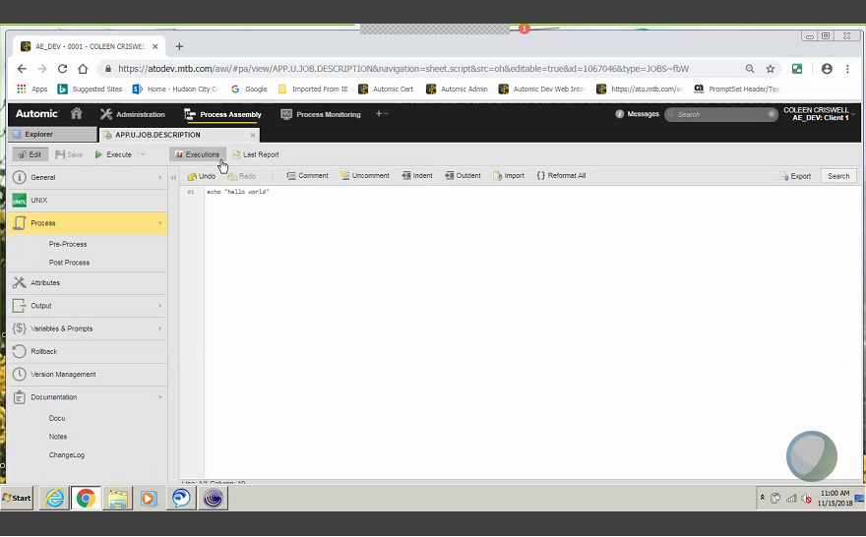

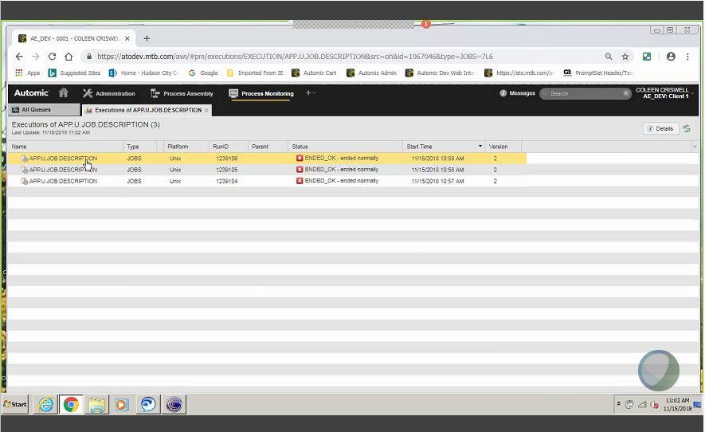

In order to view the return code of the executed job, click Details at the top right of the screen:

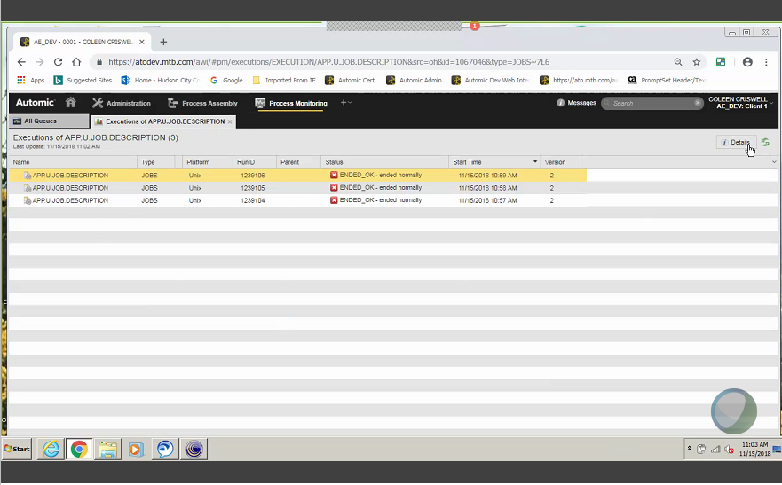

Clicking Details will bring up a listing of the job information includeing Date/Time of Execution, Date/Time of completion and return code.

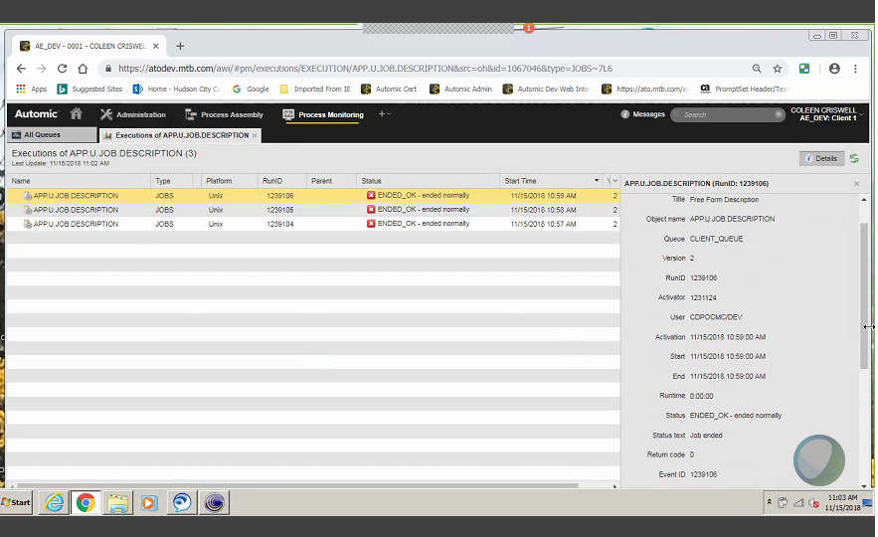

Right click the job to pull up the different options:

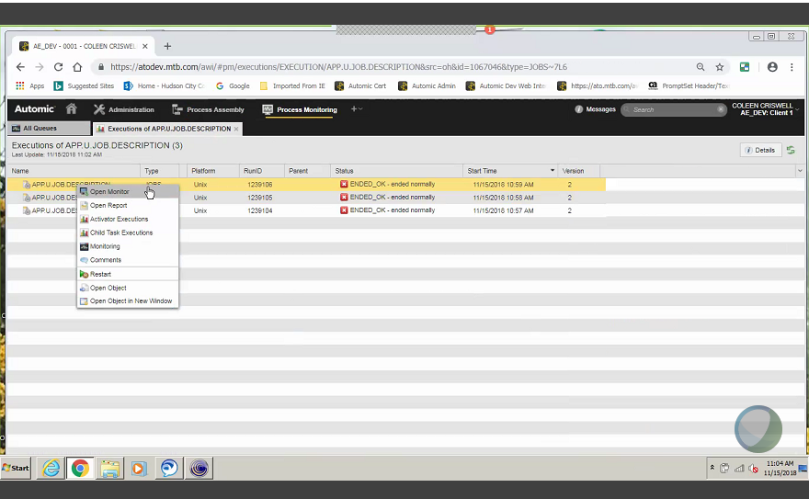

# Restarting/Canceling/Deactivating a Job

If a job fails:

Message is RED

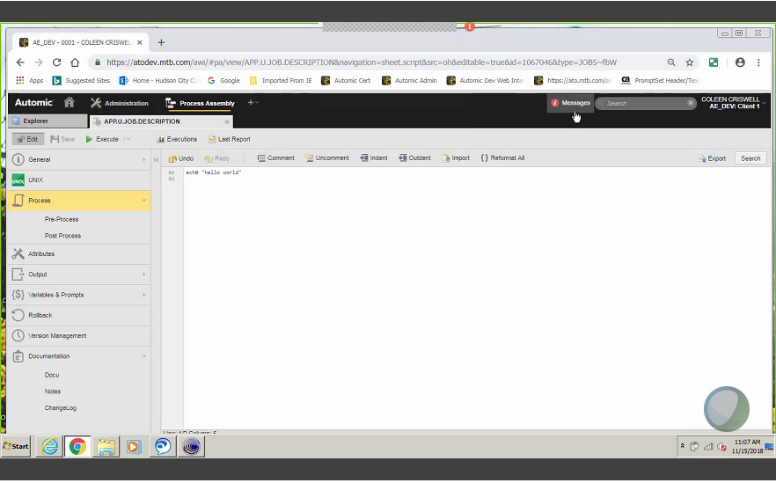

## Restart a Job

In the Process Monitoring Tabe, right click on the failed job, and select Restart from the drop down menue:

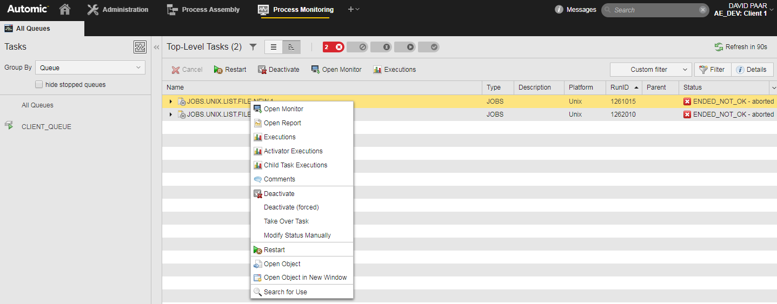

After clicking Restart, a restart options screen will open. You can choose the following options:

* Restart Point – If a process has several steps in the process tab of the Job Object, this field can specify the point for the restart to begin.
* Wait for Manual Release – Checking this box will allow for manual release of the restart. This allows the user to modify the process tab for one time only if needed. ****This option should only be used in Production to perform a one time only edit of an executing job that has failed. In Test, the changes should be permanently made to the failed job and then the job should be re-executed.
* Click RESTART

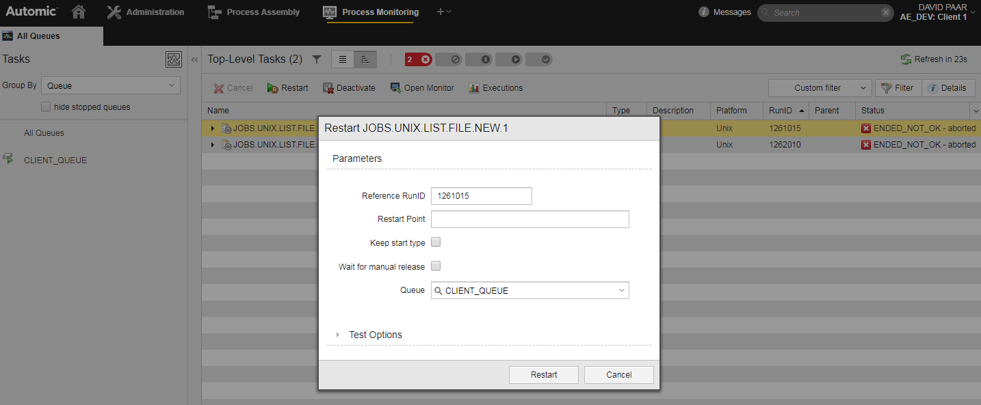

## Cancelling a Job

* The cancel option can only be utilized when a job is executing. Right click on the executing job and select:
  + Cancel – this will cancel the job only.
  + Cancel Recursive – This will cancel the job and all subsequent jobs in a workflow.

## Deactivating a Job

* In order to remove a failed job from the Process Monitoring view, the job must be Deactivated.
  + Right click on the failed job, and select Deactivate. ****Note*****cancelling an executing job will not remove the job from the Process Monitoring View. The cancelled job must be deactivated as well.

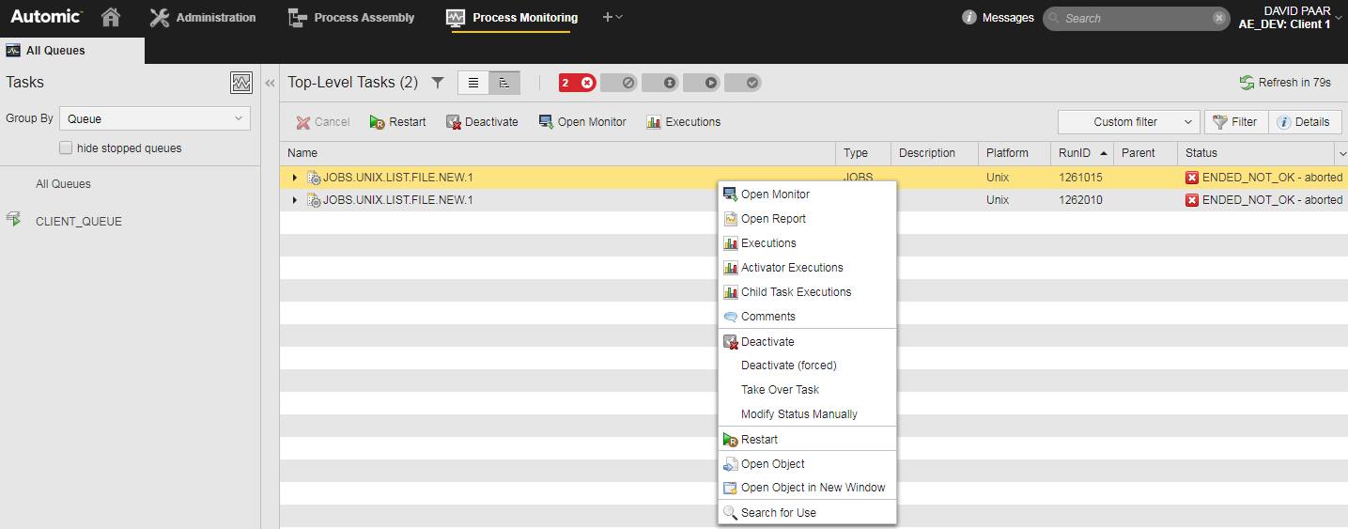

Click Restart:

